AGRO-CONNECT
AGRO-CONNECT 1
1. Scenario 3
2. Problem Statement and Objectives 3
Problem Statement: 3
Objectives: 3
3. Functional Requirements 4
User Management 4
Product Management 4
Order & Negotiation Management 4
Logistics & Delivery 4
Reviews & Ratings 4
Notifications 5
Administration 5
4. Non-Functional Requirements 6
Performance 6
Security 6
Scalability 6
Availability & Reliability 6
Usability 6
5. UML Diagrams 7
Use Case Diagram 7
Class Diagram 8
Activity Diagram 9
Sequence Diagram 10
6. Interface Design 11
Accesibility 11
Usability 11
Application of SOLID Design Principles 11
7. Version Control CI/CD 11
8. Teamwork Collaboration Structure 12
Team Roles and Responsibilities 12
Project Manager / Business Analyst 12
Backend Developer 12
Frontend Developer 12
Full-Stack / Integration Developer 12
DevOps & Quality Assurance Engineer 12
9. Tools and Collaboration Requirements 13
Version Control System 13
Issue Tracking & Project Management 13
Communication Tools 13
Continuous Integration & Deployment 14
Development Tools 14
10. Project Management 14

Scenario
AgroConnect is a centralized web-based digital marketplace designed to bridge the gap between small-scale farmers, buyers, and transporters.
- Context: Addresses market inefficiencies such as price exploitation by middlemen and poor logistics coordination.
- Target Users: Small-scale farmers (sellers), Buyers (consumers/traders), Transporters (logistics providers), and Administrators.

Problem Statement and Objectives

Problem Statement:
Small-scale farmers often struggle with fragmented supply chains, lack of direct market access, and high middleman costs. This leads to reduced profits for producers and higher prices for buyers. Additionally, coordinating logistics with reliable transporters is a manual and inefficient process.

Objectives:
- To provide a centralized digital marketplace for farmers to showcase products.
- To facilitate direct price negotiation between buyers and sellers.
- To streamline the fulfillment process by integrating a dedicated transporter role.

Functional Requirements

User Management
Users shall register and log in.
Roles include: Farmer, Buyer, Transporter, Admin
Role-based access control

Product Management
Farmers shall create and manage product listings
Products include name, quantity, price, location, availability
Buyers shall browse and search products

Order & Negotiation Management
Buyers shall place orders
Farmers may accept, reject, or negotiate prices
Order status tracking (Pending, Confirmed, Delivered)

Logistics & Delivery
Transporters shall accept delivery requests
Delivery tracking and status updates
Estimated delivery times

Reviews & Ratings
Buyers and farmers shall rate each other
Ratings affect trust and visibility

Notifications
Order updates
Price negotiation responses
Delivery status alerts

Administration
Admin shall manage users
View system analytics
Handle disputes and reports

Non-Functional Requirements
Performance
System shall support concurrent users
Order transactions processed in real time

Security
Secure authentication
Encrypted sensitive data
Role-based authorization

Scalability
Support growth in users and transactions
Containerized deployment

Availability & Reliability
99.5% uptime
Automated backups
Fault tolerance

Usability
Simple UI for low-tech users
Responsive web design
Local language support (optional)

UML Diagrams

Use Case Diagram
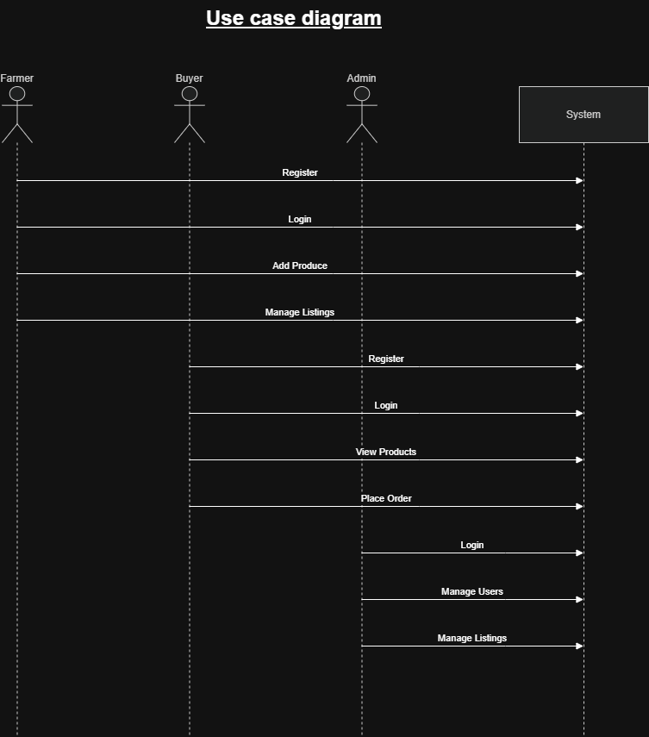

Class Diagram
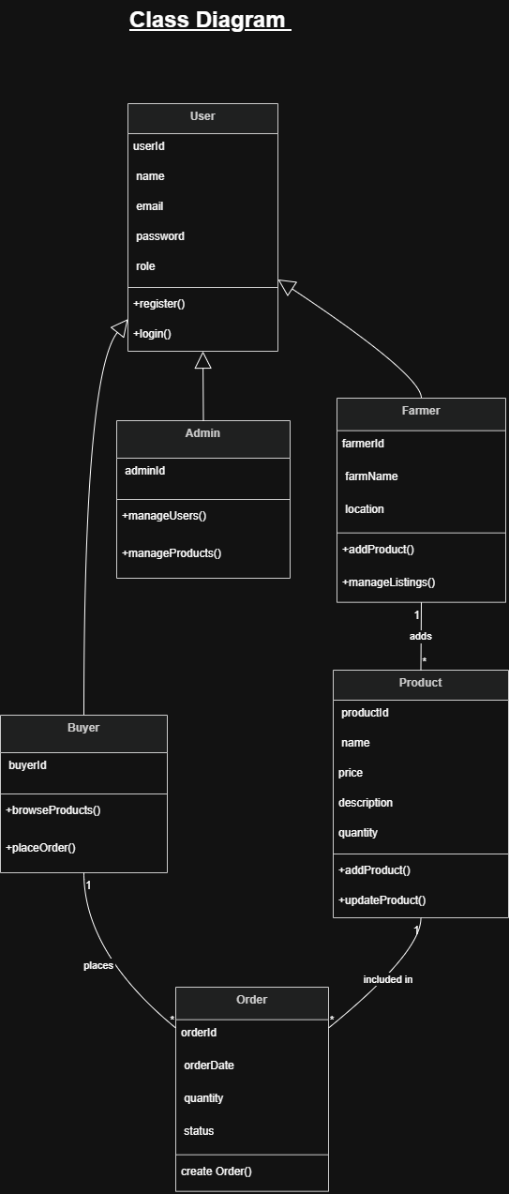

Activity Diagram
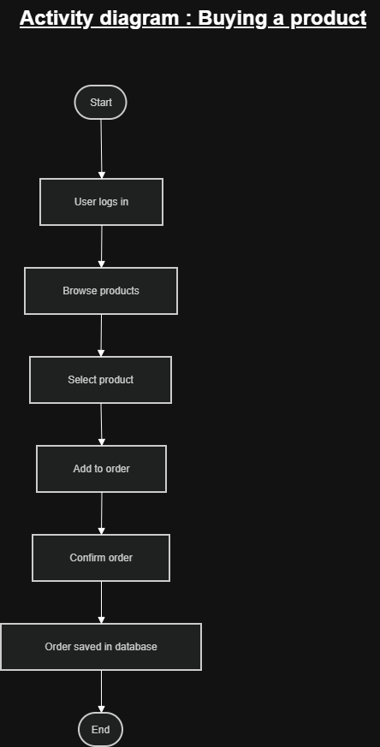

Sequence Diagram
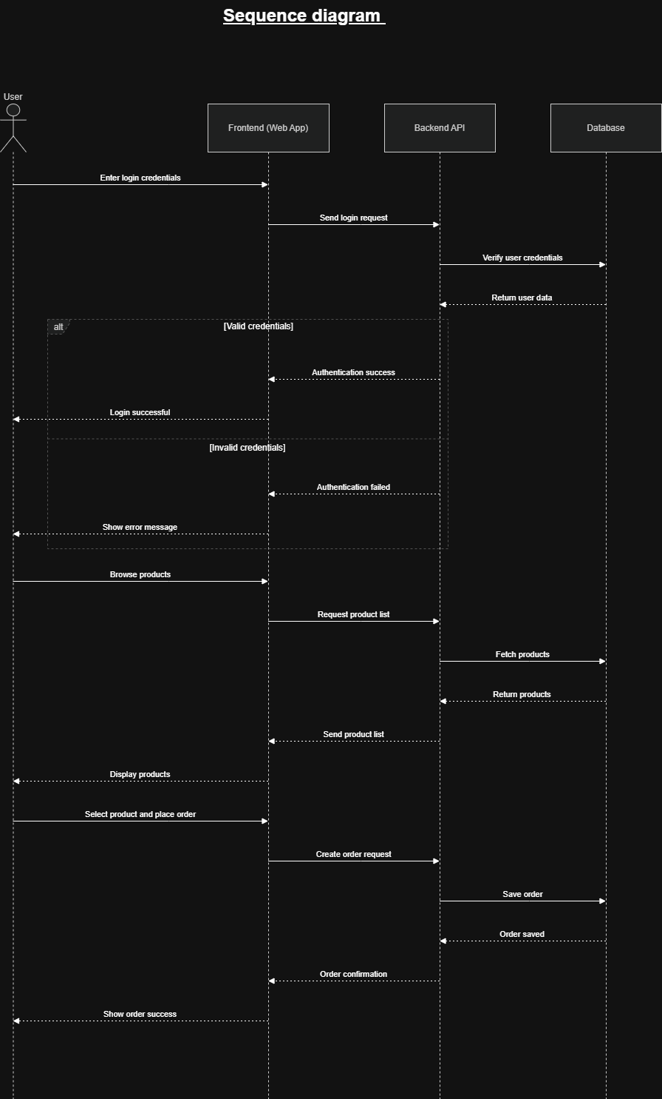

Interface Design

Accesibility
High-contrast text for outdoor visibility, support for local languages, and screen-reader compatibility for visually impaired users.

Usability
A "mobile-first" responsive design with large buttons, as many farmers may access the site via smartphones in the field.

Application of SOLID Design Principles
Single Responsibility: Separate classes for "Order Processing" and "Notification Services."
Open/Closed: The system is open to new payment gateways (e.g., M-Pesa or Credit Card) without modifying the core order logic.

Version Control CI/CD
Git Strategy: Using feature branching (e.g., feature/negotiation-module).
CI/CD Pipeline: Automated testing (Unit and Integration) triggered on every "Push" to the main branch to ensure new code doesn't break existing marketplace features.

Teamwork Collaboration Structure

Team Roles and Responsibilities
Project Manager / Business Analyst
- Requirements gathering and documentation (SRS)
- Project planning and scheduling
- Stakeholder coordination
- Risk management
- Sprint planning and reviews

Backend Developer
- Design and implement REST APIs
- Business logic (orders, pricing, delivery)
- Database design and optimization
- Authentication and authorization

Frontend Developer
- Web application development
- UI/UX design and responsiveness
- API integration
- Input validation and error handling
Full-Stack / Integration Developer
- Backend–frontend integration
- Performance optimization
- Feature integration and debugging
- Support testing and deployment
DevOps & Quality Assurance Engineer
- CI/CD pipeline configuration
- Containerization and deployment
- Automated and manual testing
- System monitoring and quality assurance

Tools and Collaboration Requirements

Version Control System
Tool: Git with GitHub
Purpose:
- Track code changes
- Enable parallel development
- Maintain version history
- Support rollback and auditing

Branching Strategy:
- main – stable production code
- develop – integration branch
- feature/* – feature development
- bugfix/* – bug fixes

Pull Requests:
- Mandatory code reviews
- Automated CI checks before merge

Issue Tracking & Project Management
GitHub Issues / Jira
Scrum-based sprints
User stories, tasks, and bug tracking

Communication Tools
Slack / Microsoft Teams – team communication
Zoom / Google Meet – meetings
GitHub Wiki / Confluence – documentation

Continuous Integration & Deployment
GitHub Actions – build and test automation
Docker – containerization
Cloud Platform – AWS / Azure / GCP

Development Tools
Backend: Node.js
Frontend: JavaScript, HTML, TailwindCSS
Database: MongoDB
API Documentation: Swagger / OpenAPI

Project Management
Timeline: 12 weeks (4 weeks Design/UML, 6 weeks Development, 2 weeks QA/Testing).
Risk Management: Identifying risks such as "low internet connectivity in rural areas" and implementing an offline-first data caching strategy.

